Supplementary data

Figure Captions

Figure 1. SEM image of the as-prepared ordered three-dimensional polystyrene (PS) colloidal crystal.

Figure 2. SEM image of the cyclodextrin-based homogeneous incorporation of Pd nanoparticles into silica with bimodal pore structure.

Figure. 3 Isotherm N₂ sorption of the cyclodextrin-based homogeneous incorporation of Pd nanoparticles into silica with bimodal pore structure.

1 μm
Y. Zhou, et al., Fig. 1
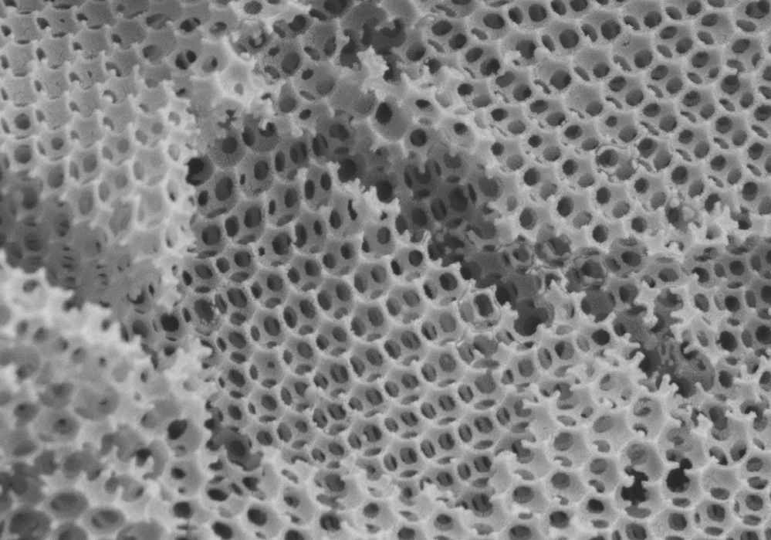
200 nm
Y. Zhou, et al., Fig. 2
Y. Zhou, et al., Fig. 3

